**Computer Vision – Homework #2**

**Image Stitching**

### Question 1

**(a) Result of set1**

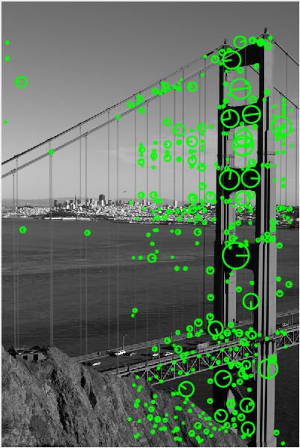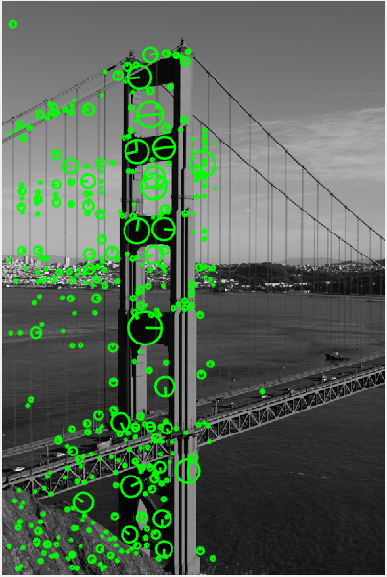

Figure 1. Reduced sets of keypoints after the ratio-test of data set 2.

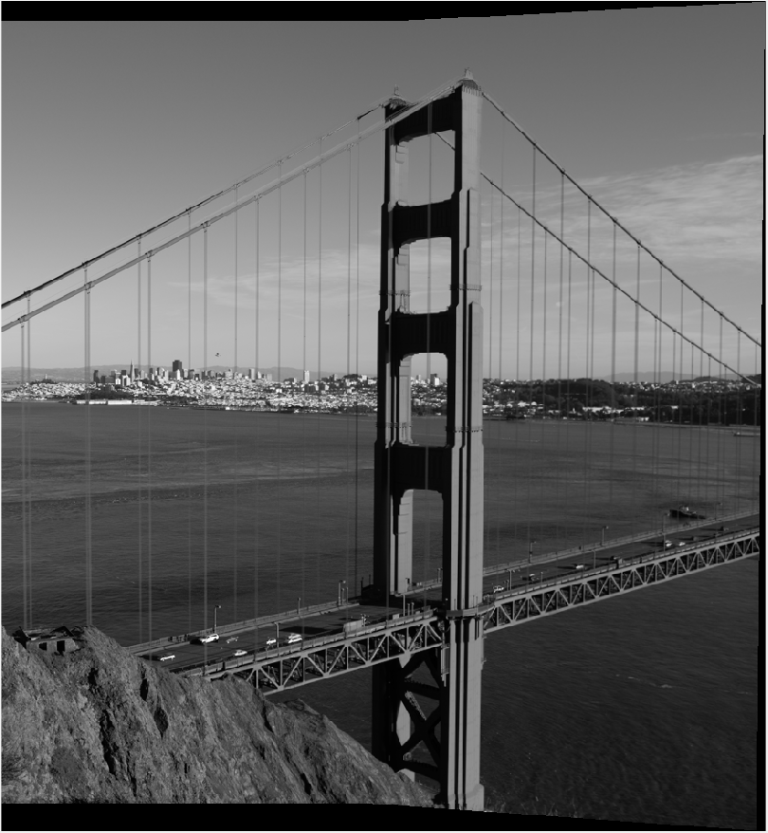

Figure 2. Image stitching result of data set 1

**(b) Result of set2**

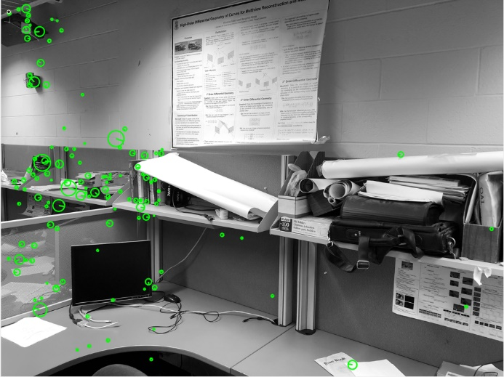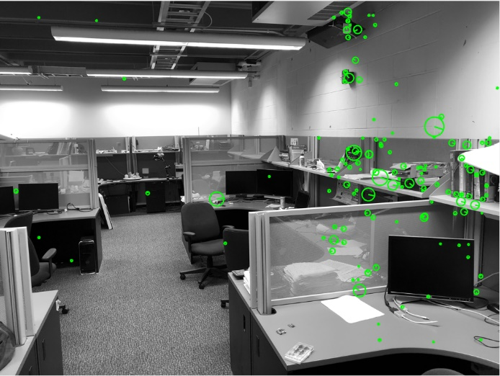

Figure 3. Reduced sets of keypoints after the ratio-test of data set 2.

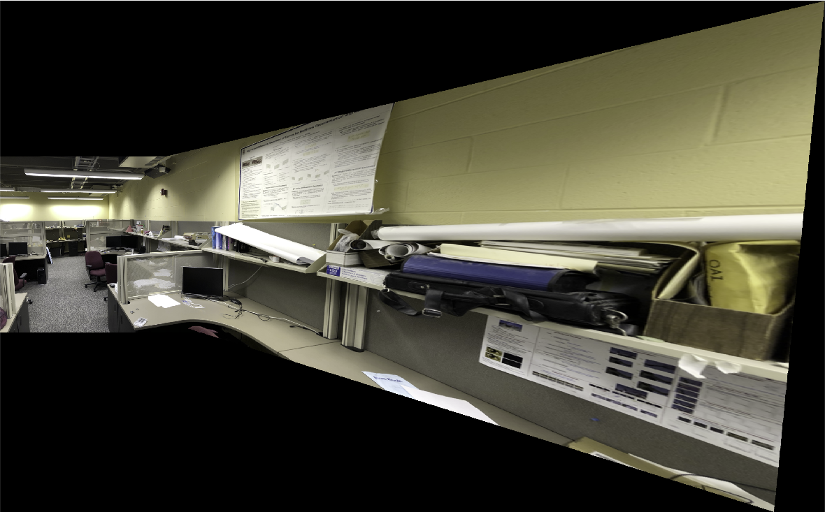

Figure 4. Image stitching result of data set 2

### Question 2

**(a) Result of set3**

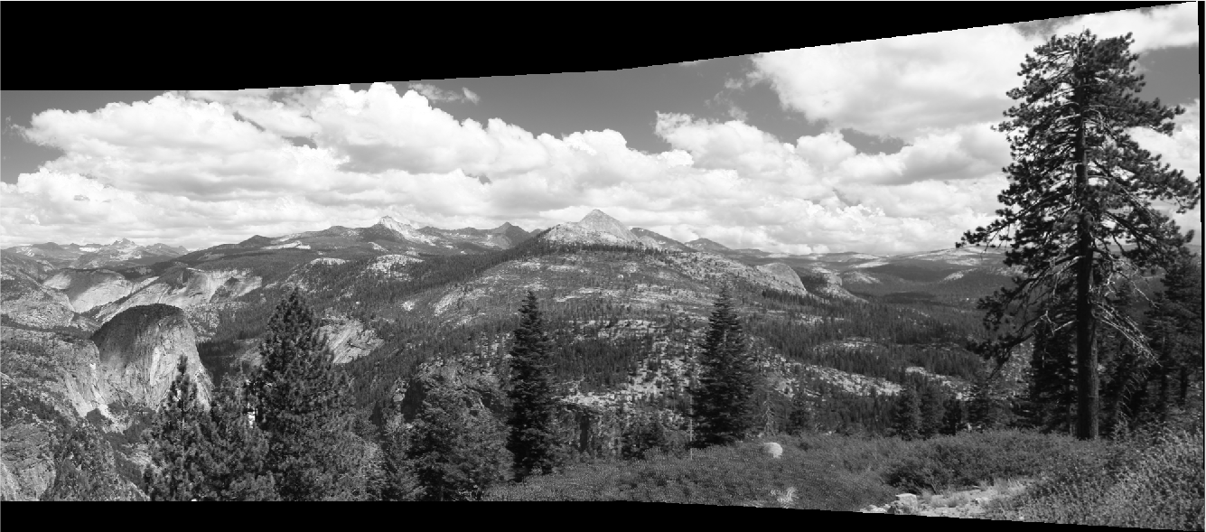

Figure 5. Image stitching result of data set 3

**(b) Result of set4**

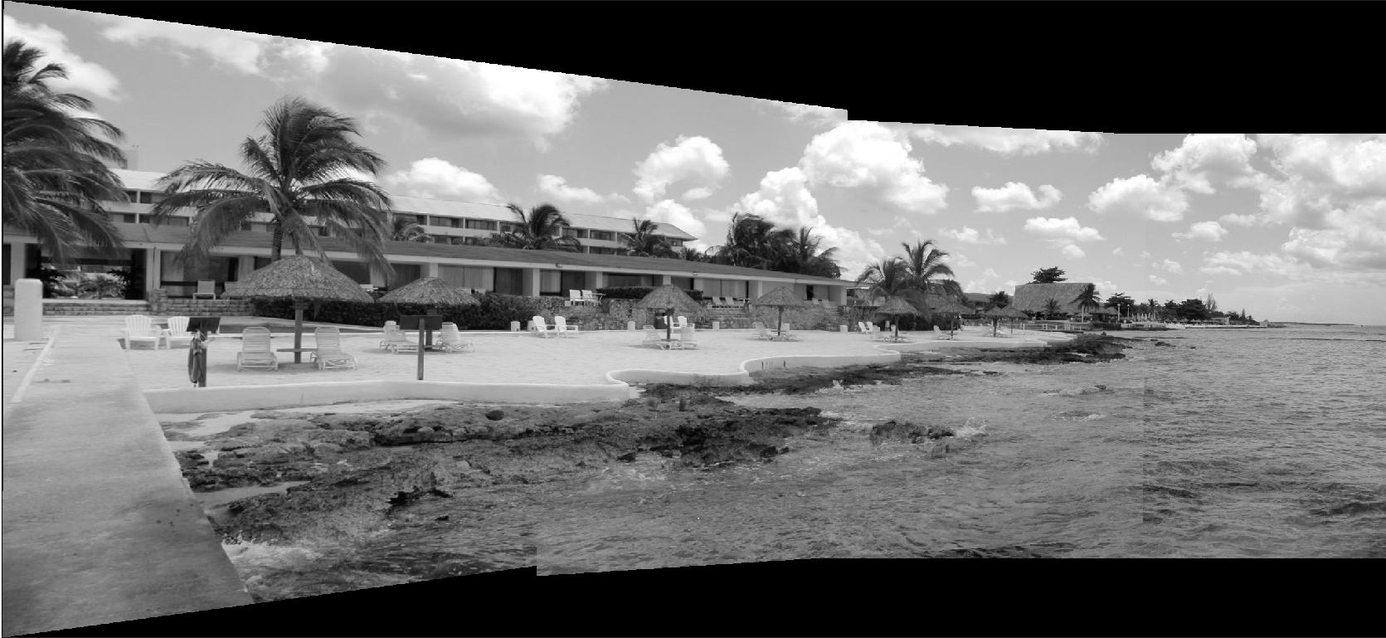

Figure 6. Image stitching result of data set 4

### Extra Credit

**(a) Blending**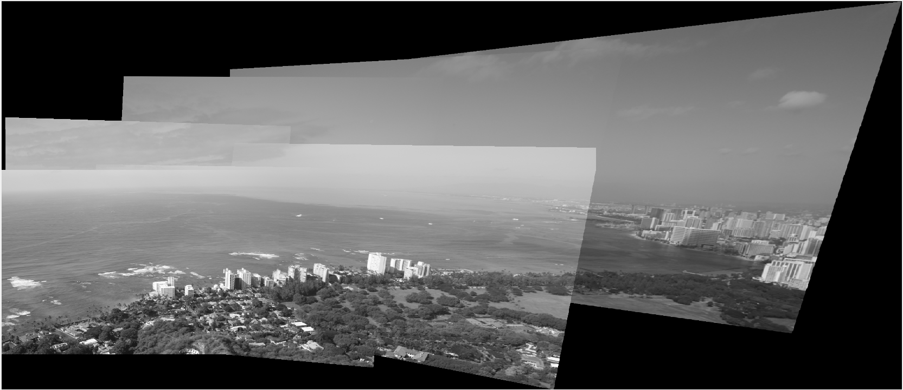

Figure 7. Image stitching result of data set “diamondhead”

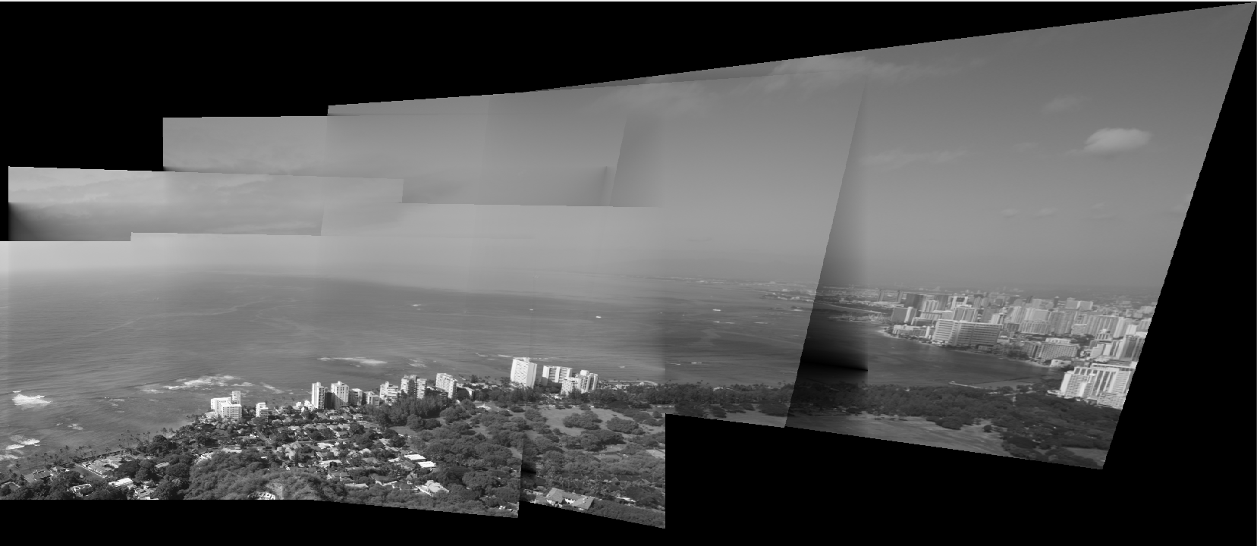

Figure 8. Image stitching result of the diamondhead dataset with the blending technique

The result seems unsatisfactory. This is because the current implementation could only used for merging two images. In this case, this implementation knows a pixel`s nearest distance to both images. However, after the merging two images to generate a new one, the boundary information of a pixel is lost. So in next merging, a pixel will use the distance to the merged image instead of old distance information about the distance to boundaries of first two images. This shortcoming is under improvement.

For merging two images, the result is pretty good. In code, when para.isBlending is set by 1, blending technique will be used.

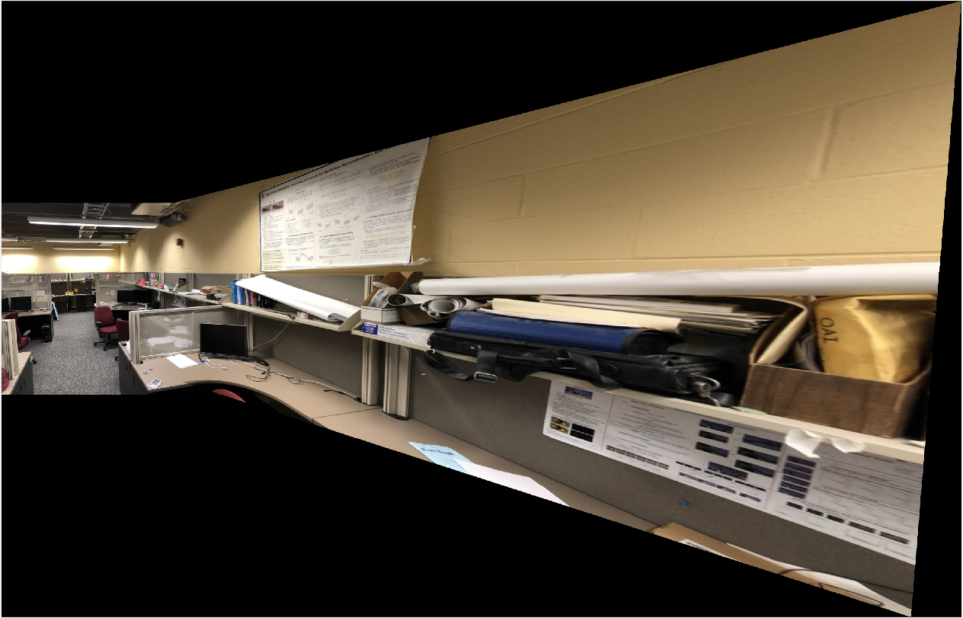

Figure 9. Image stitching result of the dataset 2 with the blending technique

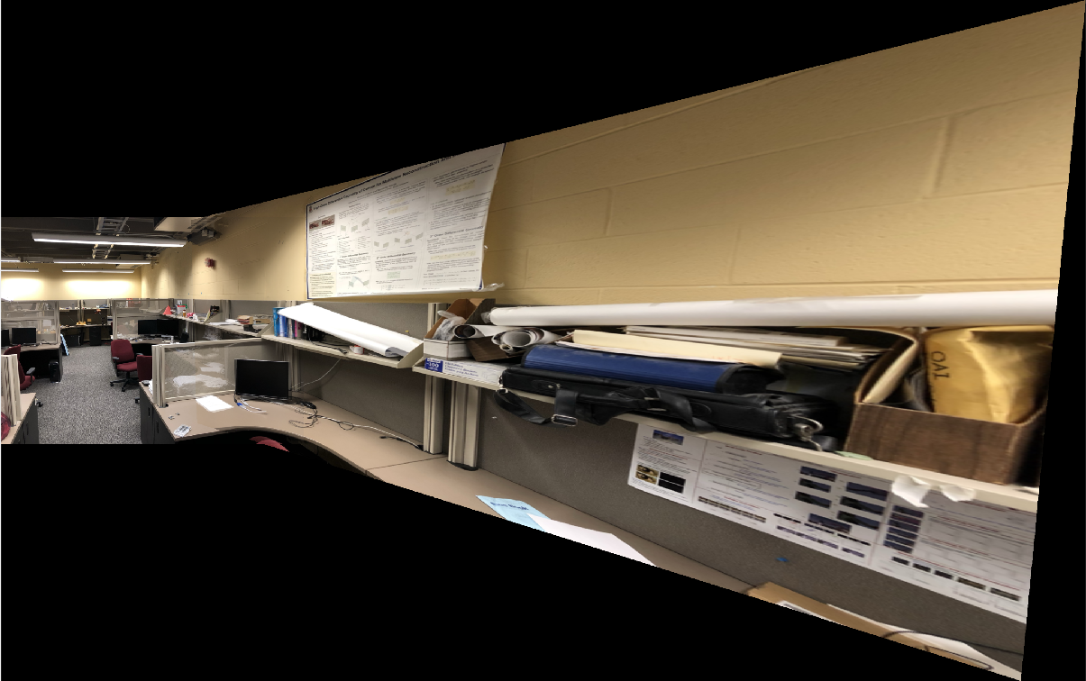

Figure 10. Image stitching result of the dataset 2 without the blending technique

**(b)**

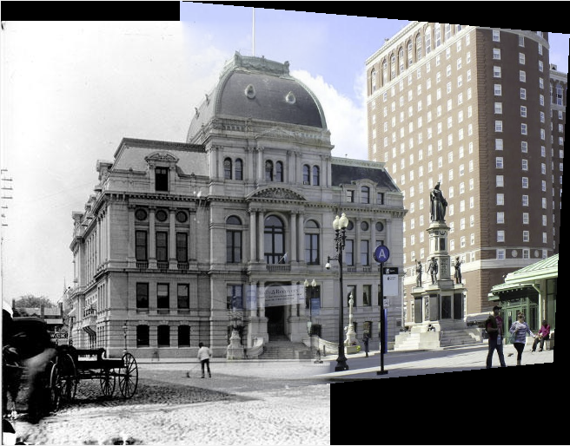

Figure 11. Image stitching result of the composite dataset with the blending technique

(c)SURF Features and Harris features

SURF Features and Harris features are used for matching and stitching images. Please set para.featureType to “SURF” to use SURF features instead of SIFT, or para.featureType to “Harris” to use Harris features.

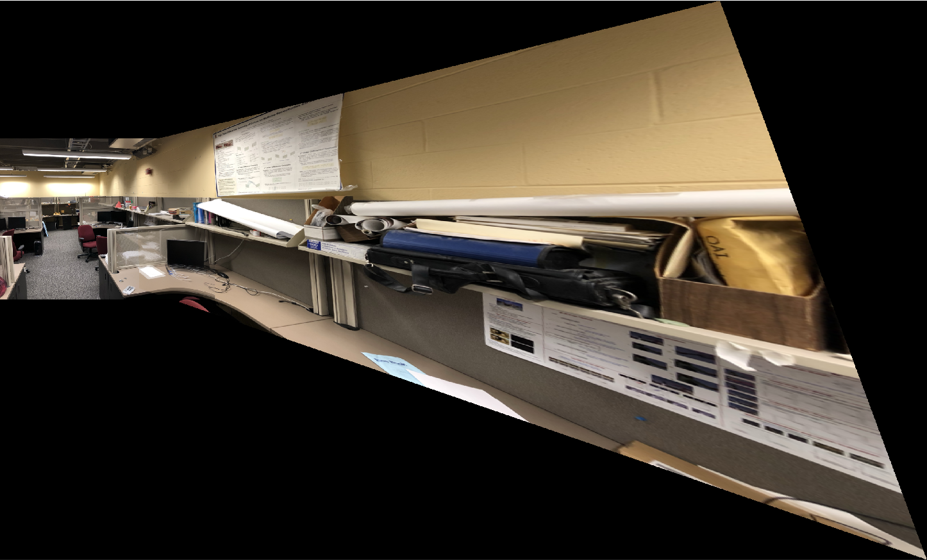

Figure 12. Image stitching result of dataset 2 based on SURF features

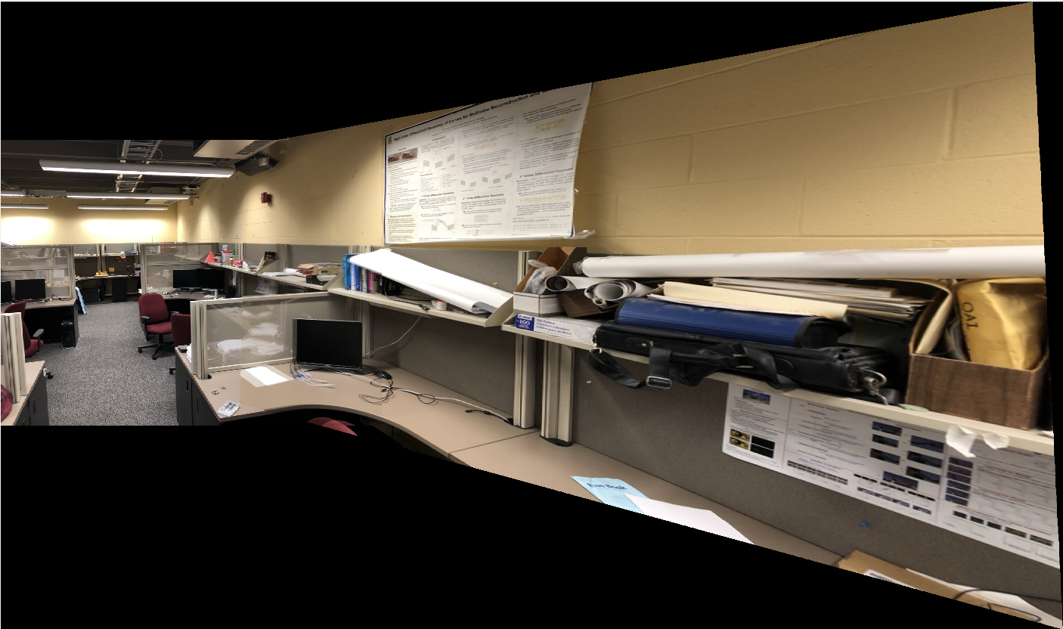

Figure 13. Image stitching result of dataset 2 based on Harris features

Generally, matching with SIFT features is better than matching with other features.

Compared with SIFT features, SURF, Harris features and other features has their own advantages.

1) Those features are easier to extract and be compared. They don`t depend on external libraries.

2) Those features are better in some specific cases, for example, SURF features are better in rotation invariant, blur and wrap transform[1], and Harris features focus on corners.

### Citations

[1] Mistry, Dr & Banerjee, Asim. (2017). Comparison of Feature Detection and Matching Approaches: SIFT and SURF. GRD Journals- Global Research and Development Journal for Engineering. 2. 7-13.